**Title**

A quantitative health impact assessment of urban greenspace and all-cause mortality across 1,041 global cities

**Authors**

Greta K. Martin1, Patrick L. Kinney2, Jennifer D. Stowell2, Susan C. Anenberg1*

1The George Washington University Milken Institute of Public Health, Washington, DC

2Boston University School of Public Health, Boston, MA

*Corresponding author: Susan Anenberg, 950 New Hampshire Ave NW, Washington DC 20015, [sanenberg@gwu.edu](mailto:sanenberg@gwu.edu)

**Keywords**

Health impact assessment, greenspace, blue space, Normalized Difference Vegetation Index, NDVI, urban nature

**Abstract**

Urban greenspaces, such as tree-lined streets and city parks, are associated with improved health and climate change resiliency. Health impact assessments of urban greenspace and mortality have been limited to American and European cities. In this study, we estimated the changes in mortality associated with observed changes in the population-weighted greenest season normalized difference vegetation index (NDVI) between 2014-2018 and 2019-2023 across 1,041 global cities representing 174 countries. We used publicly available high-resolution satellite imagery to derive estimates of NDVI and population. We combined these measures with baseline disease rates from the Global Burden of Disease study and an exposure-response function from a meta-analysis of the association between NDVI and all-cause mortality. We found that urban greenspace varies substantially by climate and geographic region. Despite modest global changes in population-weighted greenest season NDVI, urban greenspace has changed by over 20% in either direction in individual cities. These changes have resulted in a global average of 5.04 additional deaths per 100,000, ranging from 569.84 fewer to 521.82 more deaths per 100,000 across the 1,041 cities. Urban greenspace is generally higher and more stable in European and North American cities, where most epidemiologic studies and health impact assessments of NDVI and all-cause mortality have focused. Our results highlight the large variability in urban greenspace across global cities and the need to better understand the health implications of NDVI at its lower range.

**Introduction**

Urban greenspaces, such as city parks and tree-lined streets, and blue spaces, like coasts and rivers, have been linked to improvements in human health and climate resiliency. Greenspace is associated with improved mental and physical health, including reduced all-cause mortality 1. While less studied, blue space has also been linked to improved health2. Urban nature is associated with beneficial environmental outcomes such as better storm water management and heat regulation, increased biodiversity, and reductions in air pollution and ultraviolet radiation 3–6. Greenspace has generally been the focus of urban nature policies and interventions, as it is more feasible to add than blue space.

Over half of the world’s population lives in cities and this share is predicted to grow to two-thirds by 20507.Urbanization has been accompanied by the pollution of natural resources and destruction of natural environments. It is estimated that cities are responsible for over 80% of global greenhouse gas emissions 8. Although cities are the biggest contributors to climate change, they can also be effective entities of change. Cities can provide a large enough scale to create meaningful change while remaining small enough to test policies that might not be feasible at a national scale. City-level interventions to increase urban nature offer a climate adaptation strategy with health advantages.

Two studies estimating the number of deaths associated with hypothetical changes in greenspace in European and American cities indicate that increasing urban greenspace can substantially reduce mortality. A 2021 study of 978 cities in 31 European countries found that if cities were to increase their NDVI to a level equivalent with the World Health Organization’s recommendation of universal access to greenspace, 42,968 natural deaths could be avoided annually (95% CI: 32,296, 64,177) among adults 9. A 2022 study of the 35 most populous American cities found that if NDVI was increased by 0.1, 38,000 deaths (95% CI: 28,640-57,281) could have been avoided in 2019 among those aged 65 years and older 10. These studies show that urban greenspace can improve health. However, a global health impact assessment is needed to characterize the potential health benefits from increasing greenspace across a broader range of climate and regional contexts.

In 2020, The Lancet Countdown began tracking urban greenspace across a global set of cities. The Lancet Countdown is an annual publication dedicated to tracking progress towards the goals of the Paris Agreement and documenting the health implications of climate change.11 We update the Lancet Countdown methodology to capture population at a finer scale (100m instead of 1km resolution) and to remove water from the urban greenspace calculation rather than include it as zero. We further conduct a health impact assessment of the increases or reductions in deaths associated with changes in urban greenspace over time across the 1,041 global cities included in the Lancet Countdown’s greenspace analysis. We characterize urban greenspace across these cities from 2014 to 2023 and estimated the associated health impact of changes in greenspace between two five-year periods, 2014-2018 and 2019-2023. The results of this study can be used to compare greenspace across cities and time to better understand the health implications of global changes to the urban natural environment in the last decade.

**Methods**

We estimated urban greenspace using the population-weighted greenest season normalized difference vegetation index (NDVI) from 2014 to 2023, in 1,041 cities across 174 countries. We then estimated the mortality change in each city associated with NDVI changes between two five-year periods, from 2014-2018 to 2019-2023. We defined urban extents using the Global Human Settlement Urban Centre Database (GHS-UCDB), which provides a consistent methodology based on population and remote sensing data.12 Cities were included if they were the most populous in their country or had over 500,000 inhabitants. Twenty-two countries did not have cities in the GHS-UCDB and were not represented in the analysis.

*Population-weighted greenest season NDVI*

For NDVI, we used Landsat 8 satellite imagery, accessed through Google Earth Engine (GEE). Landsat data is available at the 30m resolution with new images captured approximately every 16 days for a given location. To remove cloudy pixels, we used the “Landsat.simpleComposite” algorithm from GEE. We used the Joint Research Commission (JRC)’s Landsat-derived global surface water dataset (30m resolution) to exclude pixels that were classified as “permanent water.” We used the 2015 JRC dataset to mask water pixels in the 2014-2018 images and the 2020 dataset to mask water pixels in the 2019-2023 images.

The meta-analysis we used to define the epidemiologic relationship between increased NDVI and reductions in all-cause mortality includes several large cohort studies that defined greenspace using the average NDVI value from the greenest seasons.13–15 We therefore calculated the population-weighted greenest season NDVI to align with this metric. After removing water pixels, we calculated pixel-level NDVI averages for each season: December 1 of the previous year through February 28, March 1 through May 31, June 1 through August 31, and September 1 through November 30. We averaged all Landsat images within these time periods. We combined our pixel-level average seasonal NDVI estimates with gridded population data from JRC’s 100m Global Human Settlement Layer to calculate a population-weighted seasonal average NDVI for each city (Equation 1):

Equation 1: $\frac{\sum_{i=1}^{n}{\left({NDVI}_{i}*{population}_{i}\right)}}{\sum_{i=1}^{n}{\left({population}_{i}\right)}}$.

We used the 2015 population distribution for years 2014-2018 and the 2020 population distribution for years 2019-2023. For each year, we selected the highest population-weighted seasonal average NDVI, representing the greenest or peak season, for each city.

*Health Impact Assessment*

We estimated the annual change in premature deaths (more or fewer) associated with changes (decreases or increases) in urban greenspace using a linear health impact function (Equation 2):

Equation 2: $Δmortality=y_{0}*pop*HR*Δx$,

where $Δmortality$ represents the annual change in mortality for a given city. We estimated the change in mortality using 2020 country-level baseline mortality ($y_{0}$), 2020 city population ( $pop),$ the hazard ratio of the protective association between increased NDVI and all-cause mortality (HR), and changes in population-weighted greenest season NDVI ($Δx$).

We used baseline mortality estimates from the Global Burden of Disease (GBD) 2021 study, 16 population estimates from JRC17, and a hazard ratio from a 2019 meta-analysis of longitudinal studies of the association between NDVI and all-cause mortality derived by Rojas-Rueda and colleagues.18 This study found a pooled hazard ratio of 0.96 (95% confidence interval (CI): 0.94, 0.97) for each 0.1 increase in NDVI within 500m of a person’s home among adults. Finally, we used the difference between the 2014-2018 vs. 2019-2023 population-weighted greenest season NDVI average to define changes in urban greenspace. We opted to use a five-year average rather than compare individual years, because we observed large inter-annual variability in NDVI (Fig. S1).

*Urban area groupings*

We categorize cities by geographic region using the United Nations Statistical Division sub-regional definitions (Fig. S2)19 and by climate region using the Köppen-Geiger Climate Classification System (Fig. S3).20

**Results**

The average population-weighted peak season NDVI varies greatly across global cities (Fig. 1). In the most recent 5-year period, the global average greenest season NDVI was 0.270, ranging from 0.072 to 0.580 across cities. Peak season NDVI is correlated with geographic region (Fig. S4) and Köppen-Geiger climate classification (Fig. S5). Peak-season 2019-2023 NDVI was highest on average in Melanesia (0.417), North America (0.384), and most of Europe including Eastern (0.354), Northern (0.350), and Western (0.346) Europe. Western Asia and North Africa were the least green, with regional city averages of 0.149 and 0.175 across their cities, respectively. In terms of climate classification, the average greenest season NDVI for 2019-2023 was 0.193 in arid, 0.281 in temperate, 0.319 in tropical, and 0.327 across continental cities.

Globally, the five-year greenest season average NDVI decreased slightly from 0.279 in 2014-2018 to 0.270 in 2019 to 2023, with an average city-level percent change of -0.46% (Fig. 1). Regional city averages across the two 5-year periods were also relatively stable. NDVI changed by more than 0.01 in only four geographic regions: Melanesia (-0.015), South-eastern Asia (-0.019), Sub-Saharan Africa (-0.012) and Eastern Asia (+0.014). However, these relatively small global and regional changes mask large differences across individual cities. The percent change between these two periods ranged from -22.29% to 29.38% across the 1,041 cities.



***Figure 1.*** *Population-weighted greenest season Normalized Difference Vegetation Index for 2014-2018 (panel A) and 2019-2023 (panel B) and the percent change between the two time periods (panel C) for 1,041 cities globally.*

While regional mean population-weighted peak season NDVI was relatively stable between the two periods, there was a large spread within each region and notable differences across regions in percent change (Fig. 2A). Sub-Saharan Africa had 6 of the 10 cities with the largest decreases from 2014-18 to 2019-23. By contrast, 39 of the top 50 cities with the greatest percent increase in NDVI between these two time periods were in Eastern Asia. Every region had cities that became greener and others that became less green from 2014-2018 to 2019-2023.

Globally, NDVI changes from 2014-2018 to 2019-2023 were associated with an estimated average of 5.04 (95% CI: 4.64, 5.19) more all-cause premature deaths per 100,000 annually to the 2020 population (Fig. 2B). The premature mortality impact from urban greenspace changes was not evenly distributed around the world. Changes in associated deaths closely mirrored trends in NDVI, with the largest reductions in Eastern Asia. Eastern Asia had a median reduction of 110.56 annual premature deaths per 100,000 population, though even within this region there was substantial variation across cities, ranging from 324.82 more premature deaths per 100,000 in Hiroshima, Japan to 490.92 fewer premature deaths per 100,000 in Shiyan, China. Southeastern Asia and Sub-Saharan Africa had the highest increase in health burdens, with medians of 141.93 and 80.61 more deaths per 100,000 respectively. Substantial intra-regional variation existed for these regions as well- ranging from 521.82 more deaths to 87.83 fewer deaths per 100,000 in South-eastern Asia and from 511.89 more deaths to 212.01 fewer deaths per 100,000 in Sub-Saharan Africa.



***Figure 2.*** *Percent change in population-weighted greenest season Normalized Difference Vegetation Index from 2014-2018 to 2019-2023 (panel A) and the associated changes in all-cause mortality per 100,000 population to the 2020 population (panel B) by geographic region.*

In general, cities classified as “Arid” by the Köppen-Geiger climate classification did not experience large changes in NDVI between the two time periods (median change <0.00), and thus had smaller magnitude changes in mortality associated with urban greenspace trends compared to other climates (Fig. 3). The median change in mortality associated with changes in NDVI was 0.20 fewer deaths per 100,000 (range: 300.80 fewer to 288.27 more) among arid cities. Temperate cities were similarly fairly evenly distributed between those with fewer and more deaths associated with changes in NDVI between the two time periods, but had a much larger spread than arid cities. Temperate cities had a median change of 4.94 more deaths per 100,000 (range: 490.92 fewer to 351.33 more). NDVI decreased slightly in tropical cities across the two time periods (median change -0.01), with a median of 67 more associated deaths per 100,000 (range: 256.15 fewer to 521.82 more). In contrast, continental cities became slightly greener on average in 2019-2023 compared to 2014-2018 (median change: 0.01) and had a median of 57.39 fewer associated deaths per 100,000 (range: 569.84 fewer to 343.40 more). The spread across all climate classifications spanned reduced and additional deaths.

**

***Figure 4.*** *Changes in population-weighted peak season NDVI from 2014-2018 to 2019-2023 (panel A) and associated changes mortality per 100,000 population to the 2020 population (panel B) for 1,041 cities globally by Köppen-Geiger climate classification. Density reflects the frequency of city-level values for a given change in mortality. One city classified as “Polar” was dropped from the figure (El Alto, Bolivia, 0.01 decrease in NDVI, 112.69 more deaths per 100,000 population).*

**Discussion**

We found that urban greenspace varies greatly across global cities (mean: 0.270, range: 0.072, 0.580) and is related to region and climate classification. In general, peak season NDVI was highest in European and North American cities, where health impact assessments have historically been conducted. The 2019-2023 average greenest season NDVI was 0.193 in arid, 0.281 in temperate, 0.319 in tropical, and 0.327 in continental cities. Overall, urban greenspace has remained stable from 2014-2018 to 2019-2023. However, individual cities experienced over 20% changes in either direction. We estimated that changes in NDVI from 2014-2018 to 2019-2023 were associated with 5.04 (95% CI: 4.64, 5.19) additional deaths per 100,000 across the 1,041 cities. Despite this modest global estimate, there was a large spread in the mortality changes associated with urban greenspace, with over 100-fold higher and lower death rates across individual cities.

Most epidemiologic studies of urban greenspace and health have focused on North American and European cities, where greenspace is relatively high. This could have important implications for the exposure-response function that we used, which assumes a linear relationship between NDVI and all-cause mortality across the full NDVI range. Further, we found that changes in NDVI across cities within these regions were generally smaller in magnitude than other less studied regions such as South-eastern Asia, Sub-Saharan Africa, and Eastern Asia. The impact of urban greenspace on health could be underestimated by studies focusing solely on European and North American cities.

We used NDVI to measure urban greenspace. NDVI is the most common metric used in epidemiological studies, because of its fine spatial and temporal resolution, which lends itself particularly well to longitudinal studies. However, NDVI is a function of the greenness of vegetation, which can miss important factors influencing usability such as land ownership, perceptions of safety, and infrastructure. Furthermore, we found substantial annual variation in NDVI, particularly in cities outside of arid climate zones. Differences in NDVI between two individual years are therefore more likely to reflect weather patterns rather than city-wide efforts towards urban greening. To account for these cyclical patterns, we compared differences between two 5-year periods. While our exposure definition limits the influence of weather in our estimates of NDVI, the inter-annual variation that we found highlights some difficulties with using NDVI for health impact assessments. Recent efforts to increase greenspace in some cities are likely partially masked in our study by the five-year average.

To put our results into context, we found that observed changes in NDVI were associated with 5.04 (95% CI: 4.64, 5.19) additional deaths per 100,000 to the 2020 population, with individual city contributions ranging from 521.82 more to 569.84 fewer deaths per 100,000. In 2019, the mortality burden from fine particulate matter (PM2.5), the leading environmental risk factor contributing to the global burden of disease, was estimated to be between 45-77 premature deaths per 100,000.21 While these estimates are not directly comparable, they provide an idea of the relative magnitude of the health burden from insufficient greenspace compared to the most important air pollutant for health. The estimates are not equivalent because the greenspace health impact includes deaths from all causes, while that of PM2.5 considers deaths from six causes. Furthermore, unlike other environmental hazards, there is no agreed upon standard to consider a city inadequately green. This complicates calculating the health burden of insufficient access to greenspace. Due to this issue, health impact assessments have often calculated the associated mortality from a 0.1 increase in NDVI, which is not easily understood in actionable terms. Additionally, a 0.1 increase in one setting might be very different from another in terms of feasibility due to rainfall and other climactic constraints. The urban greenspace field could benefit from future studies exploring alternative measurements to NDVI and ideal levels of greenspace for human health.

**Conclusion**

Globally, NDVI has remained relatively stable from 2014-2018 to 2019-2023. However, urban greenspace in individual cities has increased or decreased by over 20%. Changes in NDVI between these two periods were associated with 5.04 more deaths per 100,000 globally, ranging from 569.84 fewer to 521.82 more deaths per 100,000 across the 1,041 cities. Trends in NDVI likely reflect a mix of efforts to increase urban greenspace, weather, and climate change.

**Acknowledgements**

We acknowledge support from Wellcome Trust Grant No. 216075/Z/19/Z, NASA Grant No. 80NSSC21K0511, and The George Washington University.

**References**

1. Yang BY, Zhao T, Hu LX, et al. Greenspace and human health: An umbrella review. *The Innovation*. 2021;2(4):100164. doi:10.1016/j.xinn.2021.100164

2. Smith N, Georgiou M, King AC, Tieges Z, Webb S, Chastin S. Urban blue spaces and human health: A systematic review and meta-analysis of quantitative studies. *Cities*. 2021;119:103413. doi:10.1016/j.cities.2021.103413

3. Hunter RF, Cleland C, Cleary A, et al. Environmental, health, wellbeing, social and equity effects of urban green space interventions: A meta-narrative evidence synthesis. *Environment International*. 2019;130:104923. doi:10.1016/j.envint.2019.104923

4. Wolf KL, Lam ST, McKeen JK, Richardson GRA, Van Den Bosch M, Bardekjian AC. Urban Trees and Human Health: A Scoping Review. *IJERPH*. 2020;17(12):4371. doi:10.3390/ijerph17124371

5. Ampatzidis P, Cintolesi C, Kershaw T. Impact of Blue Space Geometry on Urban Heat Island Mitigation. *Climate*. 2023;11(2):28. doi:10.3390/cli11020028

6. Brückner A, Falkenberg T, Heinzel C, Kistemann T. The Regeneration of Urban Blue Spaces: A Public Health Intervention? Reviewing the Evidence. *Front Public Health*. 2022;9:782101. doi:10.3389/fpubh.2021.782101

7. Alex Baeumler, Olivia D’Aoust, Maitreyi Das, et al. *Demographic Trends and Urbanization*. World Bank; 2021.

8. Hoornweg D, Sugar L, Gomez CLT. Cities and Greenhouse Gas Emissions: Moving Forward. *Urbanisation*. 2020;5(1):43-62. doi:10.1177/2455747120923557

9. Barboza EP, Cirach M, Khomenko S, et al. Green space and mortality in European cities: a health impact assessment study. *The Lancet Planetary Health*. 2021;5(10):e718-e730. doi:10.1016/S2542-5196(21)00229-1

10. Brochu P, Jimenez MP, James P, Kinney PL, Lane K. Benefits of Increasing Greenness on All-Cause Mortality in the Largest Metropolitan Areas of the United States Within the Past Two Decades. *Front Public Health*. 2022;10:841936. doi:10.3389/fpubh.2022.841936

11. Romanello M, Napoli C di, Green C, et al. The 2023 report of the Lancet Countdown on health and climate change: the imperative for a health-centred response in a world facing irreversible harms. *The Lancet*. 2023;402(10419):2346-2394. doi:10.1016/S0140-6736(23)01859-7

12. Freire S, Schiavina M, Corbane C, et al. GHS-UCDB R2019A - GHS Urban Centre Database 2015, multitemporal and multidimensional attributes. Published online January 28, 2019. doi:10.2905/53473144-B88C-44BC-B4A3-4583ED1F547E

13. Nieuwenhuijsen M, Gascon M, Martinez D, et al. Air Pollution, Noise, Blue Space, and Green Space and Premature Mortality in Barcelona: A Mega Cohort. *IJERPH*. 2018;15(11):2405. doi:10.3390/ijerph15112405

14. Crouse DL, Pinault L, Balram A, et al. Urban greenness and mortality in Canada’s largest cities: a national cohort study. *The Lancet Planetary Health*. 2017;1(7):e289-e297. doi:10.1016/S2542-5196(17)30118-3

15. Zijlema WL, Stasinska A, Blake D, et al. The longitudinal association between natural outdoor environments and mortality in 9218 older men from Perth, Western Australia. *Environment International*. 2019;125:430-436. doi:10.1016/j.envint.2019.01.075

16. Global Burden of Disease Collaborative Network. Global Burden of Disease Study 2019 (GBD 2019) Reference Life Table. Published online 2021. doi:10.6069/1D4Y-YQ37

17. WorldPop. Population Counts 2020 UN-Adjusted Constrained 1 Available from: www.worldpop.org/doi/10.5258/SOTON/WP00660.

18. Rojas-Rueda D, Nieuwenhuijsen MJ, Gascon M, Perez-Leon D, Mudu P. Green spaces and mortality: a systematic review and meta-analysis of cohort studies. *Lancet Planet Health*. 2019;3(11):e469-e477. doi:10.1016/S2542-5196(19)30215-3

19. United Nations Statistics Division. Standard Country or Area Codes for Statistical Use (M49). https://unstats.un.org/unsd/methodology/m49

20. Beck HE, Zimmermann NE, McVicar TR, Vergopolan N, Berg A, Wood EF. Present and future Köppen-Geiger climate classification maps at 1-km resolution. *Scientific Data*. 2018;5:180214. doi:10.1038/sdata.2018.214

21. Southerland VA, Brauer M, Mohegh A, et al. Global urban temporal trends in fine particulate matter (PM2·5) and attributable health burdens: estimates from global datasets. *The Lancet Planetary Health*. 2022;6(2):e139-e146. doi:10.1016/S2542-5196(21)00350-8

**Supplemental Material**

***Figure S1.*** *Population-weighted greenest season average NDVI from 2014-2023 by geographic region.*

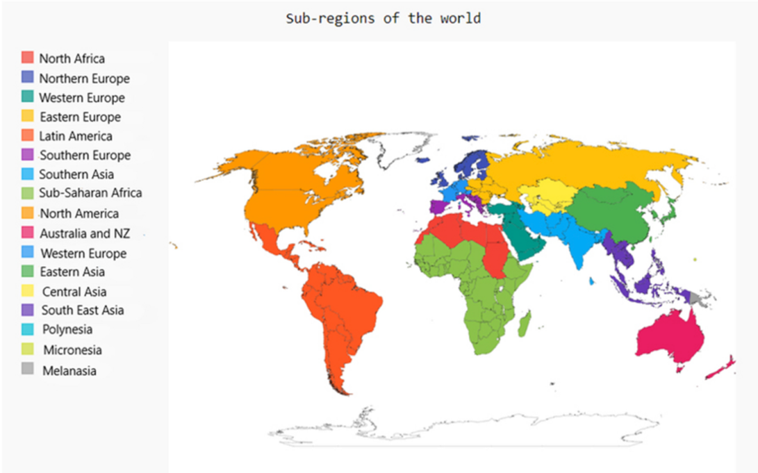

***Figure S2.*** *Map of the world by geographic region classification.*

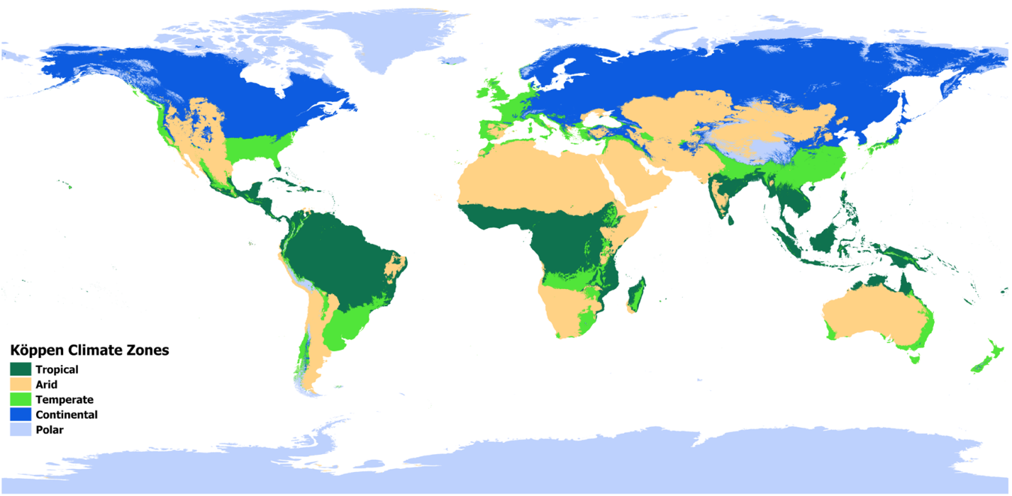

***Figure S3.*** *Map of the world by Köppen-Geiger climate classification.*



***Figure S4.*** *Population-weighted greenest season 2019-2023 average NDVI by geographic region.*

**

***Figure S5.*** *Population-weighted greenest season 2019-2023 average NDVI by Köppen-Geiger climate classification. One city classified as Polar was dropped (El Alto, Bolivia, 0.107).*